**Design Thinking**

**Abstract**

Investment is a major driver of economy as well as the most reliable source of steady income for the future in developing nations like India. However, according to data from the National stock exchange (NSE), there are 1.2 crore active investors in India, a country of 138 crore people as of August 2021 which is less than 1% of the total population. One major factor that keeps Indians away from investing in stock markets is the lack of knowledge about it. A lot of people have this assumption that stock market is something that is hard to crack. That thought could be rooted from the basic fact that nobody has ever tried to make them understand what the stock market is and how investing in it works. A major contributing factor behind this is the length of financial documents and the use of complicated terminologies and jargons that seem alien to a layman investor. With this premise in mind, we try to take the design thinking approach to summarize financial documents to make investment easy and accessible to all potential investors.

**Problem Context**

F

**Understanding the Problem**

The first class on ‘Understanding the Problem’ was an eye opener for us as we were coming into the course with already a solution in our minds regarding what we wished to develop. However, this flawed method was soon put to rest, and we decided to look at our problem more deeply from different perspectives before thinking about the solution. The first step on this path was ‘**The 5 Why’s Approach’** which helped us to get to the root of the problem.

**The 5 Why Approach**

The following are the highlights of our discussion from the 5 Why Approach:

* We realised that our problem is valid because financial documents like annual reports and IPO documents are lengthy texts with a lot of details and contain jargons that all the investors don’t have the time to read thoroughly and comprehend before investing.
* We realised that this was an issue because financial documents are meant to be source of information for not just casual investors but for other stakeholders like financial analysts, media, shareholders, mutual funds, government agencies, etc. The documents are supposed to cater to plethora of stakeholders and thus there is a need to provide a lot of information in as concise a manner as possible. Thus, the documents contain jargons to avoid unnecessary elaboration of widely understood financial terminologies.
* Steering our thought process in another direction we questioned more fundamentally about our problem to understand why this is an issue at all and does it need a solution. We came to a realisation that in today’s fast-moving world, where people need a quick and easy solution to their problems, a concise document for financial analysis could be a key factor in promoting investments in equity markets on a large scale. To take an analogy, people who find reading newspapers boring and tedious, try to keep themselves informed by reading short news articles on platforms like InShorts or through social media websites like Twitter.
* Finally, we concluded that if we are able to summarise the long and laborious financial documents in a concise and meaningful manner that is comprehensible to a layman investor, it could be helpful in making smart and informed investment decisions and eventually result in turning investment into a habit rather than a job that is left to the experts.

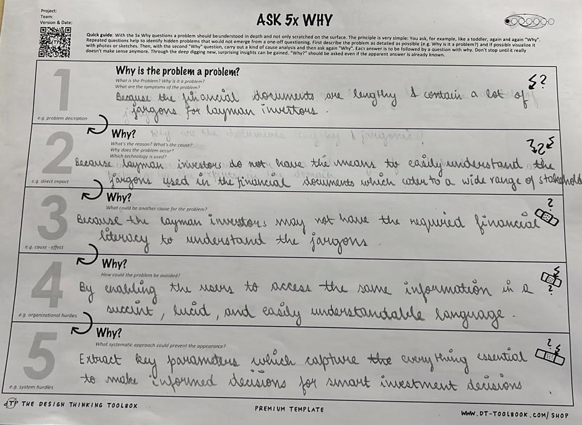

**The 5 WH Questions Exercise**

While the 5 why exercise helped us get to the root of our problem and why a solution is worth the effort and time, the 5WH questions was another interesting exercise that we undertook alongside the previous one. This exercise helped us identify all the potential stakeholders in the problem that we are trying to address, and the different kinds of questions stimulated our minds to look at the problem from the perspectives of those stakeholders which eventually helped us gain new insights and define our final problem statement precisely. The following are the highlights of the 5WH questions exercise which lasted for about 30 mins:

* **Who?** – These questions helped us identify not only potential customers but all the other stakeholders in the solution that we were working towards. The companies who publish these documents and government agencies like SEBI and RBI that set the guidelines for these documents and regulate their content are the major stakeholders that we rely upon for information. Apart from layman investors who would like to have more information on the company’s work, its investments, and future plans before investing, another potential customer that we identified in the course of this exercise was financial analysts working in big/small companies, mutual fund managers who have to go trough all these documents before taking decisions. A cursory glance at a summarised document could be useful tool in their arsenal.
* **What?** – Prompted us look at our problem from a different mindset. We realised that not only is the length of the documents and their use of esoteric terminologies an issue, but language is also a major barrier in a multilingual country like India where most people learn to read and write in their native languages whereas the documents are published mostly in English.
* **When?** – Thinking about when the problem became a real challenge, we realised that in the past few years as economic growth has picked up pace in India and the purchasing power of people has increased. With surplus money at hand, there is natural tendency to invest but the common man lacks the necessary knowhow to make these investments.
* **Where?** – Helped us get a clearer understanding of our target users from a vague picture. We identified that people within a certain income and age bracket who do not have access to financial advisors but wish to make informed investments decisions and would like to know more about the company that they are about to invest in are our primary target.
* **Why?** – This exercise was already thoroughly conducted in the previous section where were able to identify the root cause of the problem and the need for a solution in the space. We also identified that the reason the problem had not been solved as yet was due to the technical difficulties involved in making such a solution possible. Linguistic models which have the capability to summarise large documents into a concise and meaningful piece of text have attained the desired levels of accuracy only recently.
* **How?** – The how questions helped us think about our problem and the potential solution from a technical perspective where we pondered about the different ways in which we could make our solution available and accessible. We realised that apart from the technical offering that we intended to provide through the use of linguistic machine learning models, we also needed to identify how to make it most easy for common potential investors to get access to this solution.

